**COMSATS University Islamabad, Lahore** **Campus**

**Assignment-4 – Spring 2024**

|  |  |  |  |  |  |  |  |  |  |
| --- | --- | --- | --- | --- | --- | --- | --- | --- | --- |
| Course Title: | Computer Network | | | | Course Code: | CSC110 | | Credit Hours: | 3(3,0) |
| Course Instructor/s: | Dr Tariq Umer | | | | Programme Name: | BS Software Engineering | | | |
| Semester: | 5th | Batch: | FA22-BSE-C | Section: | C | Date: | 06-12-23 | | |
| **Dead line** |  | | | | **Maximum Marks:** | | **15** | | |

Q1- a- Draw a routing table entry on each router for 2 iterations. Moving from A to D



b – Consider the following network. With the indicated link costs, use Dijkstra’s shortest-path

algorithm to compute the shortest path from x to all network nodes. Show how the algorithm

works by computing a table similar to Table 5.1 .

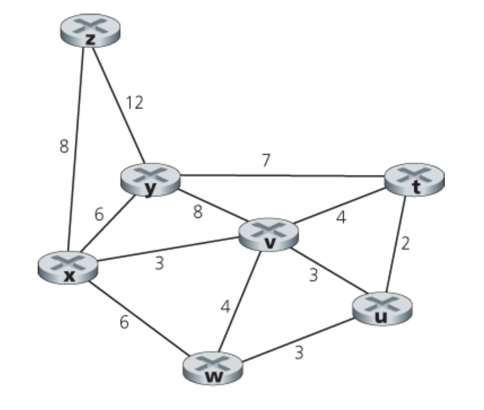

c-





d. **Consider the network scenario given below, suppose there is another router *w*, connected to routers *y* and *z*. The costs of all links are given as follows: c(x,y)=4, c(x,z)=50, c(y, w)= 1, c(z, w)= I, c(y,z)=3. Suppose that poisoned reverse is used in the distance vector routing algorithm.**

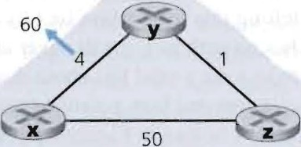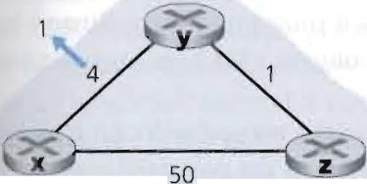

**1** When the distance vector routing is stabilized, router w, y, and z inform their distances to x to each other. What distance values do they tell each other?

2. Now suppose that the link cost between x and y increases to 60. Will there be a count-to-infinity problem even

if the poisoned reverse is used? Why or why not? If there is a count-to-infinity problem, then how many iterations are needed for the distance-vector routing to reach a stable state again? Justify your answer. (5)

**3.** How do you modify c(y,z) such that there is no count-to-infinity problem at all if c(y, x) changes from 4 to 60?